Design Journal

File Name: Ring.SLDPRT
Description: Part in underground water sprinkler
Material: Plastic

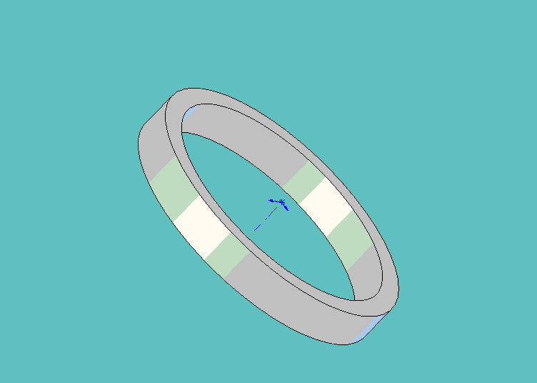 1. Extruded main part of ring w/ circles
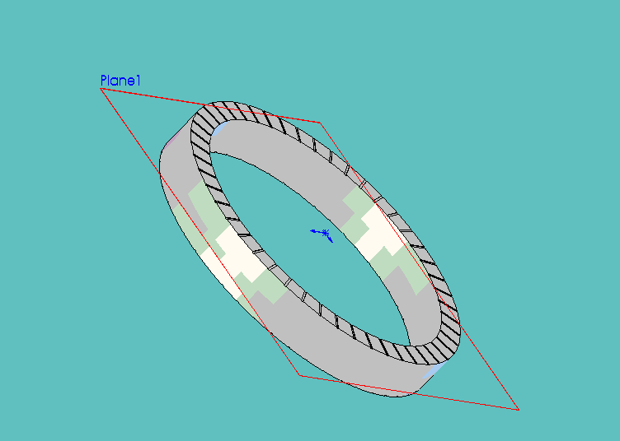2. Made one cut into ring and then used circular pattern to make the rest of them, made a plane in the center or ring and mirrored features to other side.

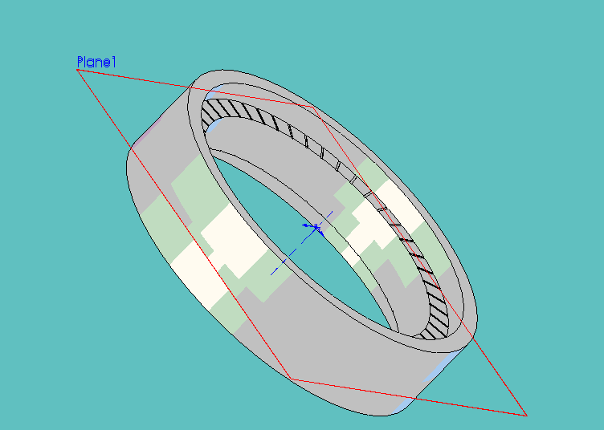3. Extruded outer part of ring.
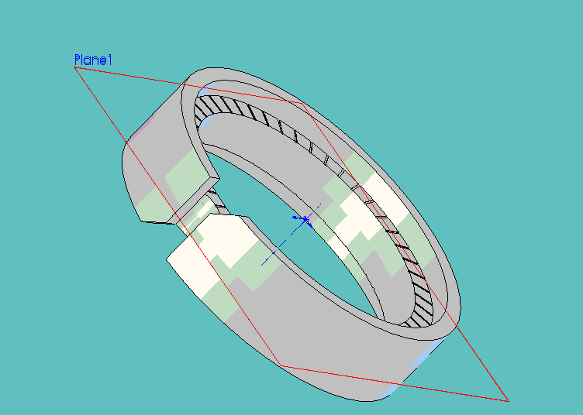4. Made cuts on side of ring.
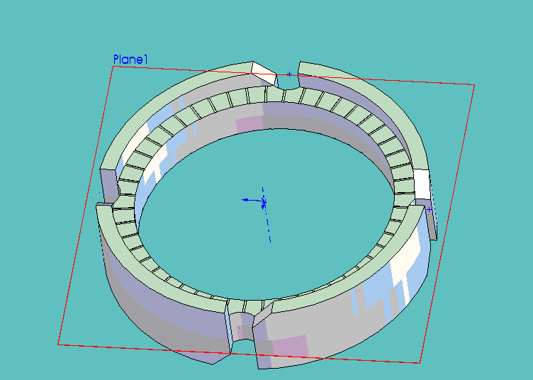5. Used circular pattern to copy the extruded cut features.

